Offline Classics Tech Design Doc

CISC 3171: Introduction to Software Engineering

Instructor: Alec Maelstrom
Term: Spring, 2026
Members: Ethan Jonas
Lawrence Ma
Edmond Liu

Context
This document describes the technical design for Offline Classics, a mobile app capable of full operation in a setting without access to the internet.

The primary challenge for this project is that the app must be lightweight and deliver at least three fully operational, independent games that are enjoyable and playable in either a short commute or an environment where internet access is scarce. The solution is that the app will be a modular, single-app design where each game is an isolated instance, launched from a shared navigation layer.

Architecture Design
Architecture Diagram
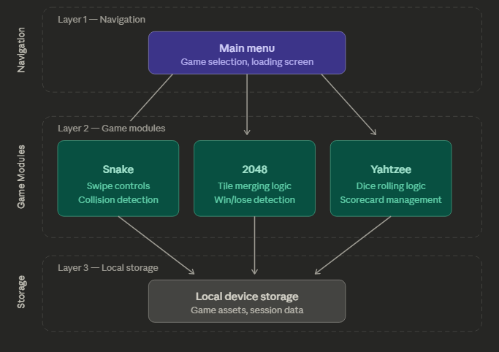

Key Architectural Decisions

- Modular game architecture: Every game is constructed as an independent Godot scene. Future games can be added by simply adding a new scene without affecting any already-existing ones, and a bug or modification in one game cannot impact another. Instead of creating each game as a stand-alone application, which would have required duplicating the navigation and loading logic over three different codebases, this was strongly recommended.
- No persistent data between sessions: No scores or game states will be saved by the app. When a player leaves a game, all of the game's states are deleted from memory. This adheres to the fundamental design philosophy of keeping the program lightweight and greatly simplifies the architecture. Progress saving and high score monitoring are specifically postponed until later iterations.
- Single Navigation Layer- All game modules are controlled by a single navigation layer; the main menu scene is the only element in charge of starting and stopping games. It is not possible to go straight from one gaming scenario to another. This strengthens the modular design by establishing a single, predictable navigation flow and keeping each game module independent of the others. The main menu scene is used for all return-to-menu logic, including the confirmation popup that alerts the player to the loss of progress.
- All assets bundled at install time - All game assets are packaged with the app at install time rather than fetched at runtime. This is necessary to guarantee complete offline functionality from the moment the app is opened. The tradeoff is a slightly larger install size, but this is acceptable given that offline availability is a core requirement of the application.

Technology Stack
Layer | Choice
Mobile Framework | Godot
Language | GD script
Platform | Mobile
Storage | Local device storage

System Components

Main Menu Components

Main Menu Screen
- Container for menu interface.

Header
- Display app title and settings button

Game Selection Panel
- Select Yahzee, Snake, 2048 to play

NavigationManager
- Handles transition from Main Menu to selected games, settings; and back.

Yahtzee

Dice Manager
- Handles dice rolling
- Generates random values (1-6)
- Tracks held dice

Score Manager
- Calculates scores for all categories:
  - Ones – Sixes
  - Three/Four of a Kind
  - Full House
  - Small/Large Straight
  - Yahtzee
- Tracks used categories
- Checks for endgame condition fulfilment

Turn Manager
- Control turn flow: player -> bot -> repeat
- Rolls reset after each turn

Bot Engine
- Uses a predetermined rule based decision-making system
- Difficulty can handicaps bot
  - Ex: Easy -> Bot doesn’t hold dice
  - Medium -> Bot only rolls max 2 times per turn
  - Hard -> Everything goes

UI Manager
- Updates:
  - Dice visuals
  - Scorecards
  - Buttons like roll, # of rolls and game states

Snake Game Engine Components

GamestateManager
- Snake body positions
- Current direction
- Score
- Food/powerup positions
- Game over state
- Pause state

MovementManger
- Advance snake based on powerup
- Direction change
- Prevent illegal movement

CollisionManager
- Wall collision
- Self collision
- Cross food/powerup

SpawnManager
- Spawn food in valid position
- Spawn powerup in valid position
- Remove from position

Snake Client Components

UI/View Components
- Start screen - title, start, settings
- Game screen - board, snake, food, score, pause
- Pause overlay - resume, volume, startover, quit
- Game over screen - game over message, final score, startover, quit
- Settings screen - volume, quit

NavigationManager
ex. display the start screen when the app launches, return to the game screen when gameplay resumes
- Current active view
- Transition between view

2048 Game Engine Components

- Board
Owns the 4x4 grid and controls the tiles on it. Responsible for detecting swipes, sliding tiles in the swiped direction, processing the merges resulting from the swipes from the leading edge as well as spawning a new tile in a randomly selected, empty cell after each swipe. Communicates with the Game Manager to report when a 2048 tile has been created or when no valid moves remain.
- Game Manager
Responsible for the starting and ending of 2048 games. It initializes the board, tracks the player’s score, the highest tile value and the total number of swipes made during the session. Listens for win and loss signals from the Board and transitions the game to the end state when either condition is met. Communicates with Timer, Options Menu and Game End Screen.
- Timer
Responsible for tracking the duration of the current game session. The timer is paused when the options menu is open and then resumes again once it has been closed. It starts the timer once the game has been initialized and stops the timer when either a win or loss condition occurs. Displays the timer on the screen and sends resulting time to the Game End Screen to be displayed.
- Options Menu
Responsible for presenting the player with the ability to restart the game or return to the main menu. Emits a signal to the Game Manager when opened and closed so the timer can be paused and resumed accordingly.
- Game End Screen
Responsible for displaying the outcome of the game — win or loss message, final score, time played, highest tile value, number of swipes, and buttons for restarting or returning to the main menu.

Data Design

Menu
ScreenType:
{
mainMenu,
yahtzee,
snake,
game2048,
}

MenuOption:
{
String label,
String imagePath,
ScreenType destination,
}

Yahtzee
All game data is stored in memory during runtime
GameState:
{
current_turn: "player" | "bot",
dice: Array<Integer>,
held_dice: Array<Boolean>,
rolls_remaining: Integer,
player_scorecard: Scorecard,
bot_scorecard: Scorecard
}

Dice ex:
Integer array : dice = [1,2,3,4,5]
Boolean array : Held_dice = [true, false, false, true , true]

Scorecard structure:
{
Ones: Integer or null,
twos: Integer or null,
threes: Integer or null,
Yahtzee : Integer or null
}

Snake
ScreenType:
{
start,
game,
pause,
gameOver,
}
Direction:
{
up,
down,
left,
right,
}
Position:
{
int x,
int y,
}
BoardConfig:
{
int width,
int height,
}
ItemType:
{
food,
speedBoost,
slowDown,
bonusPoints,
}
Item:
{
ItemType type,
Position position,
int pointValue,
}

SnakeState:
{
List<Position> snakeBody,
Direction currentDirection,
List<Item> items,
int score,
bool isGameOver,
bool isPaused,
}

2048
Grid Size:
const GRID_SIZE = 4

Game State:
enum GameState {
IDLE,
ACTIVE,
WIN,
LOSS
}

Board(4x4 grid):
class Board {
var grid: Array[Array[Tile]]
var state: GameState
var empty_cells: Array[Vector2i]
}

Tile:
class Tile {
var value: int
var position: Vector2i
var merged: bool
}

Game Session:
class GameSession {
var board: Board
var score: int
var highest_tile: int
var swipe_count: int
var time_elapsed: float
var state: GameState
}
Detailed Design

Menu
From | To | Trigger
mainMenu | yahtzee | User selects the Yahtzee button
mainMenu | snake | User selects the Snake button
mainMenu | game2048 | User selects the 2048 button
mainMenu | settings | User selects the Settings button
yahtzee | mainMenu | User exits Yahtzee and returns to menu
snake | mainMenu | User exits Snake and returns to menu
game2048 | mainMenu | User exits 2048 and returns to menu

Yahtzee

From | To | Trigger
mainMenu | Initiate Game | Play button
Initiate Game | Player Turn | Game starts
Player Turn | Player Turn | Player rolls dice or holds dice
Player Turn | Bot Turn | Player selects a scoring category
Bot Turn | Bot Turn | Bot rolls dice and evaluates holds
Bot Turn | Player Turn | Bot selects a scoring category
Player Turn | Game Over | All score categories filled
Bot Turn | Game Over | All score categories filled
Game Over | Initiate Game | Play again button
Game Over | Main Menu | Home button

Snake

INPUT TABLE

Message Type | Payload | Description
START_GAME | {} | Starts a new Snake session; Initializes the snake body & direction.
CHANGE_DIRECTION | { direction } | Updates the snake’s movement direction; Reversing is illegal.
TICK_UPDATE | { currentDirection, activeEffects } | Advances snake based on direction and powerup.
SPAWN_ITEM | { item } | Spawns a food item or power-up item at a valid unoccupied board position.
FOOD_COLLISION | { item } | Remove item on collision; Extend Snake; Update Score.
POWERUP_COLLISION | { item } | Remove powerup on collision; active powerup effect.
WALL_COLLISION | { position } | Detect and end game on wall collision.
SELF_COLLISION | { position } | Detect and end game on self collision
PAUSE_GAME | {} | Pauses the game and displays Pause overlay.
RESUME_GAME | {} | Resumes the game from Pause state.
GAME_OVER | { score } | End game; display final score; option to restart or quit.
RESTART_GAME | {} | Resets the current Snake session and starts a new game.
QUIT_TO_HOME | {} | Ends the current Snake session and returns the user to the home screen.

STATE CHANGE TABLE

From | To | Trigger
mainMenu | start | Player selects Snake from main menu
start | game | Player selects Start Game
game | pause | Player selects Pause
pause | game | Player selects Resume
pause | start | Player selects Quit
game | gameOver | Snake collides with wall
game | gameOver | Snake collides with its own body
game | game | Snake consumes food
game | game | Snake consumes power-up
game | game | Player changes direction
game | game | System processes tick update
gameOver | game | Player selects Restart
gameOver | start | Player selects Quit

2048

FROM | TO | TRIGGER
Idle | Active | Game is initialized and board is displayed
Active | Active | Player swipes and a valid move is made
Active | Win | A 2048 tile is detected after a swipe
Active | Loss | No valid moves remain after a swipe
Win | Idle | Player presses restart
Loss | Idle | Player presses restart
Win | Main Menu | Player presses main menu button
Loss | Main Menu | Player presses main menu button

User Experience WireFrames

Menu

MAIN MENU LOADING SCREEN

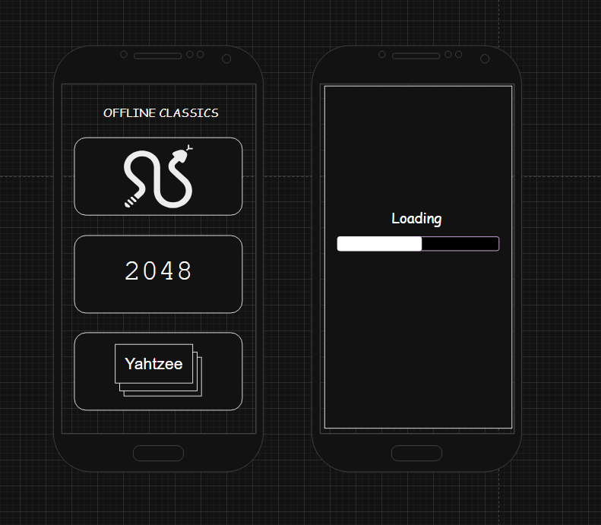

Yahtzee

Start screen

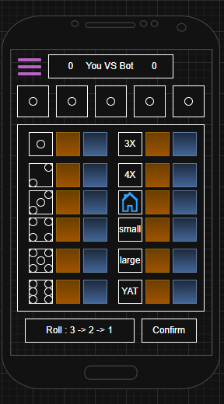
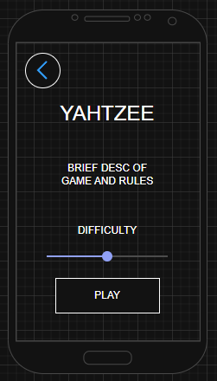

(player) Start state example:

Bot turn state example:

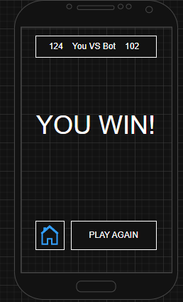
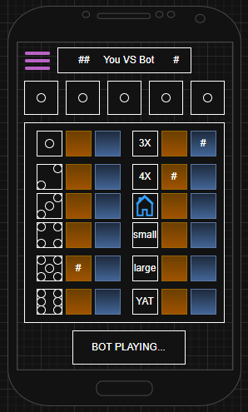

Game End Screen example:

Snake

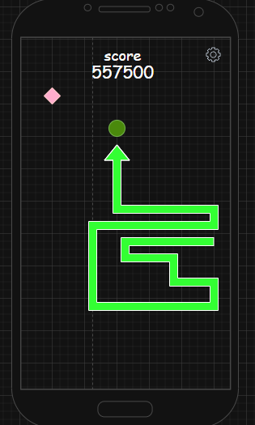
GAMEPLAY SCREEN

PAUSE SCREEN
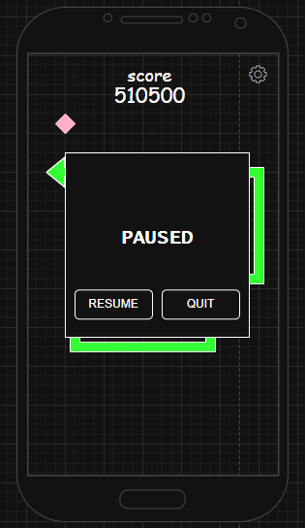

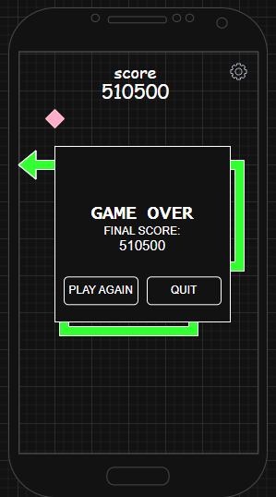

GAME OVER SCREEN

2048
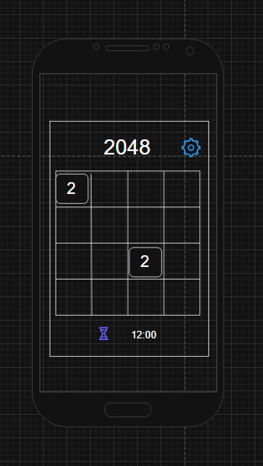

Gameplay Screen

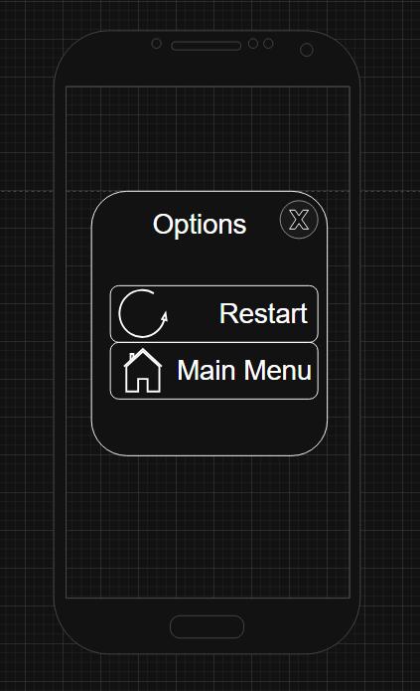

Options Screen

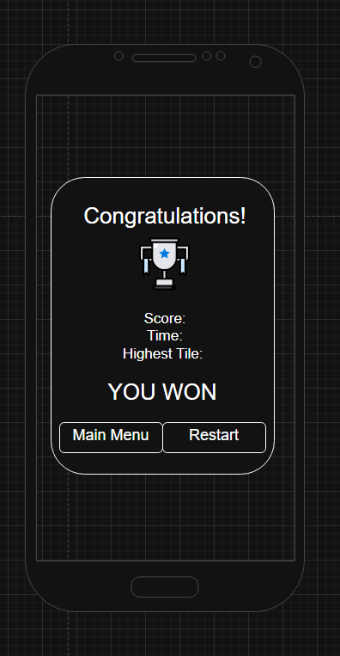

Congratulations Screen

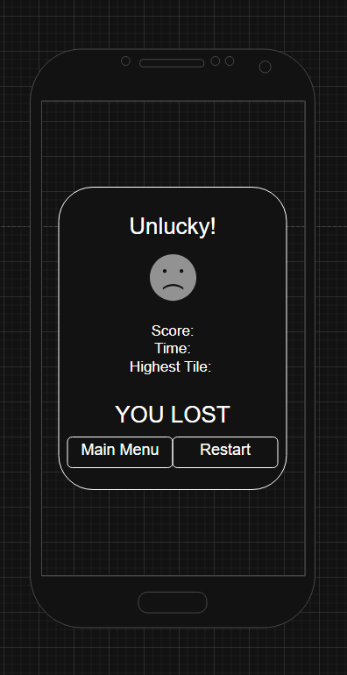

Lose Screen

Key Decision Log

- Godot as the development framework
  - Decision: The application will be developed entirely using Godot and GDScript.
  - Reason: Godot provides built-in support for UI, input handling, and mobile deployment, allowing the team to avoid learning multiple framework
  - Impact: Simplifies development and enables a single unified codebase, reducing integration complexity
- Modular Scene-Based Architecture
  - Decision: Each game (Yahtzee, Snake, 2048) will be implemented as an independent scene.
  - Reason: Separating games into modules allows team members to work in parallel without conflicts.
  - Impact: Improves maintainability and scalability, making it easier to add new games in the future.
- No Persistent Data
  - Decision: Game progress and scores will not be saved between sessions
  - Reason: Persistence adds complexity that is not essential to core gameplay
  - Impact: Reduces scope and allows the team to focus on core mechanics
- Bundling assets at install time
  - Decision: All game assets will be bundled with the application at install time.
  - Reason: The application is designed for offline use, where internet access may be unavailable. Bundling assets ensures that all games function immediately without requiring additional downloads.
  - Impact: Increases the initial application size slightly, but guarantees full functionality offline and reduces runtime dependencies.

